SUPPLEMENTARY MATERIAL/DATA

Agarose Gel electrophoresis
- Samples 1 - 40
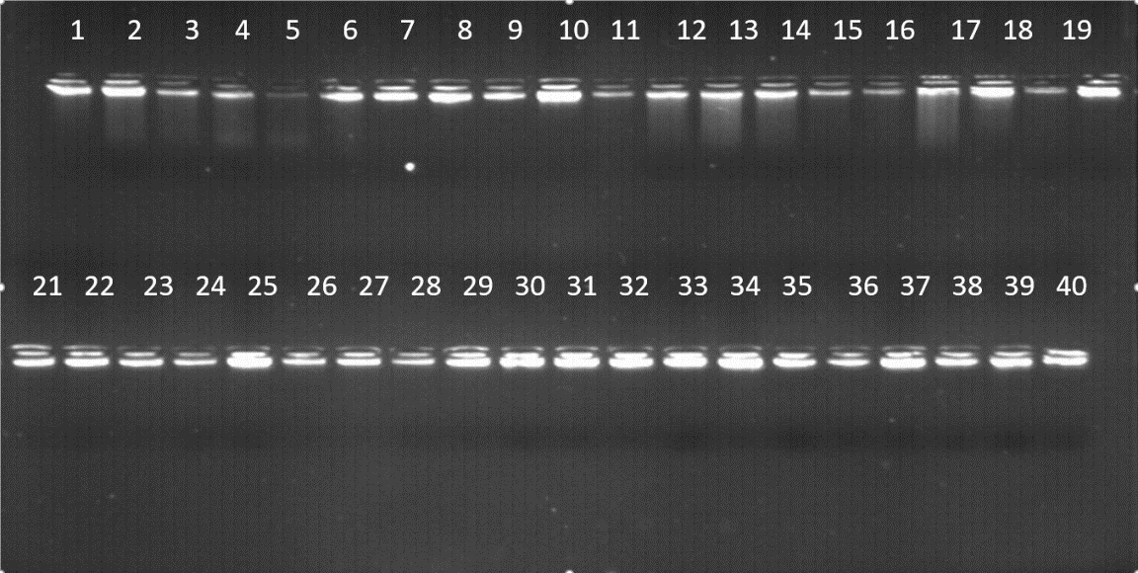
Figures 1
- Samples 41 – 60
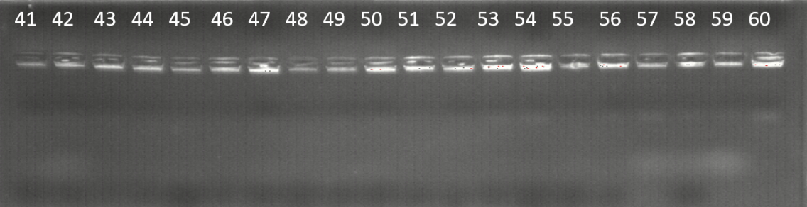 Figures 2
Figures 1 and 2. DNA quantification agarose gels showing presence of DNA

